MIT Wristband Could Make AC Obsolete
By Kyle Vanhemert 10.30.13 9:30 AM

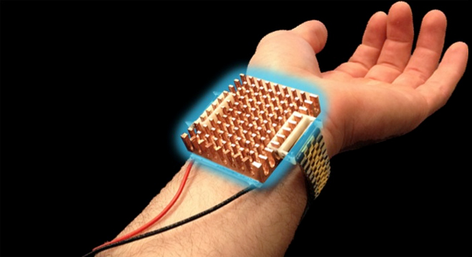
The Wristify prototype is a personal climate-controlling wearable. Image: Wristify
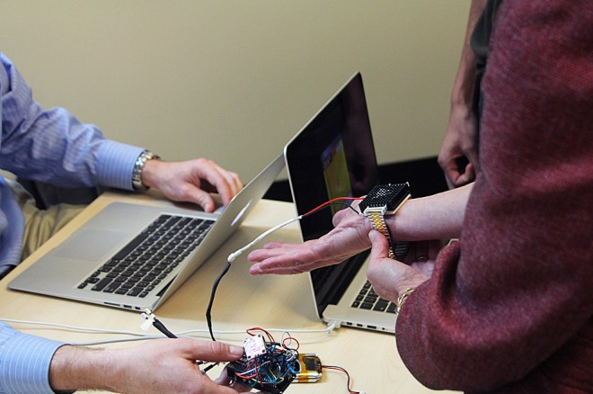
The team’s now turning to refining the design. Shames says the same effect could be produced with half the surface area. Photo: Franklin Hobbs
The Wristify prototype is a personal climate-controlling wearable. Image: Wristify

Here’s a scary statistic: In 2007, 87 percent of households in the U.S. used air conditioning, compared to just 11 percent of households in Brazil and a mere 2 percent in India. Another one: By 2025, booming nations like those are projected to account for a billion new consumers worldwide, with a corresponding explosion in demand for air conditioning expected to arrive along with them. Keeping indoor spaces at comfortable temperatures requires a huge amount of electricity–especially in sweltering climates like India and Brazil–and in the U.S. alone it accounts for a full 16.5 percent of energy use.

All of that adds up to a big problem. At a point when humans need to take a sober look at our energy use, we’re poised to use a devastating amount of it keeping our homes and offices at the right temperatures in years to come. A team of students at MIT, however, is busy working on a prototype device that could eliminate much of that demand, and they’re doing it by asking one compelling question: Why not just heat and cool our bodies instead?

Shames runs hot. His mom runs cold. He figured there must be a way for them to coexist.
Wristify, as they call their device, is a thermoelectric bracelet that regulates the temperature of the person wearing it by subjecting their skin to alternating pulses of hot or cold, depending on what’s needed. The prototype recently won first place at this year’s MADMEC, an annual competition put on by the school’s Materials Science and Engineering program, netting the group a $10,000 prize, which they’ll use to continue its development. It’s a promising start to a clever approach that could help alleviate a serious energy crisis. But as Sam Shames, the MIT senior who helped invent the technology, explains, the team was motivated by a more prosaic problem: keeping everyone happy in a room where no one can agree where to set the thermostat.

Shames runs hot. His mom runs cold. He figured there must be a way for them to coexist peacefully. So he started researching, digging into physiology journals to get a better understanding of how we experience temperature. One paper held the key to the Wristify concept. It detailed how locally heating and cooling different parts of the body has all sorts of effects on how hot or cold we are–or, more accurately, how hot or cold we think we are. “There’s a big perceptual component to it,” Shames says.

“The human body and human skin is not like a thermometer. If I put something cold directly on your body at a constant temperature, the body acclimates and no longer perceives it as cold.” Think of what happens when you jump in a lake. At first, it’s bracingly cold, but after a while, you get used to it. By continually introducing that sudden jolt of cold, Shames discovered, you could essentially trick the body into feeling cold. Wristify basically makes you feel like you’re continually jumping into the lake–or submerging into a hot bath.

In building the prototype, Shames and his co-inventors–Mike Gibson, a second-year Ph.D. student; David Cohen-Tanugi, a fourth-year Ph.D. student, and Matt Smith, a postdoctoral researcher–had the challenge of figuring out how to best exploit that perceptual tick. The research suggested that anything with a temperature change greater than 0.1 degree Celsius per second would produce the effect. Their wristband, which harnesses thermoelectrics to both heat and cool a patch of skin, is capable of changing that surface at a rate of 0.4 degrees Celsius per second.

They’re still refining the cycles used to deliver that temperature change–right now, Shames says, they’ve settled on roughly 5 seconds on, 10 seconds off. Along the way they had the chance to test it on all sorts of friends, family and classmates, and Shames says that people could definitely feel the technology at work. “The most common reaction you get is that you see someone smile,” he says.

The group is keen to push the product forward. In its current state, the device is very much a prototype–a crude mess of electronics strapped to a cheap, fake Rolex band. But none of the components are prohibitively expensive–the prototype works with about $50 worth of off-the-shelf parts–and Shames says they could produce the same effect with about half the on-the-skin surface area used by the current version. “The focus on our development thus far has been technical proof of concept,” Shames says, but they’re committed to turning Wristify into a real product. “We’ve been thinking long and hard about the next best steps to pursue,” he says. “One thing we’re really conscious about is the aesthetics of our device. It has to look good and it has to be comfortable.”

If it comes together, though, it would be a compelling sell–a wearable that offered personalized, dynamic climate control. It might not solve the AC energy problem in one fell swoop, but it could nudge us away from the central-heating-and-cooling mindset that is taking us there–more of a next-gen fan or handwarmer than a full heating and cooling replacement. It’s certainly an intriguing approach. As Shames says, “Why heat or cool a building when you could heat or cool a person?”

