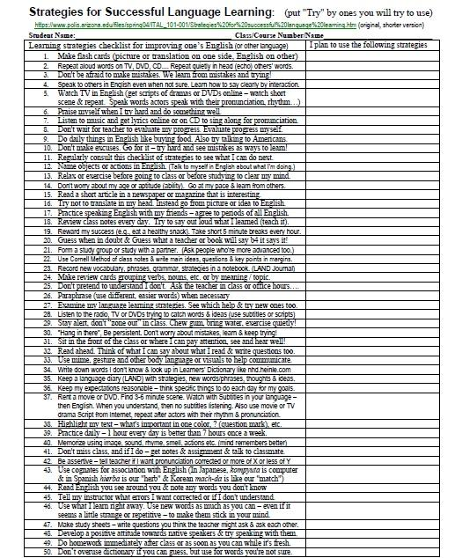

Learning strategies checklist for improving one’s English (or other language) - see below for original format. Source:https://www.polis.arizona.edu/files/spring04/ITAL_101-001/Strategies%20for%20successful%20language%20learning.htm

50 Language Learning (LL) Strategies
1. Make flash cards (picture or translation on one side, English on other)
2. Repeat aloud words on TV, DVD, CD.... Repeat quietly in head (echo) others' words.
3. Don't be afraid to make mistakes. We learn from mistakes and trying!
4. Speak to others in English even when not sure. Learn how to say clearly by interaction.
5. Watch TV in English (get scripts of dramas or DVDs online – watch short scene & repeat. Speak words actors speak with their pronunciation, rhythm…)
6. Praise myself when I try hard and do something well.
7. Listen to music and get lyrics online or on CD to sing along for pronunciation.
8. Don't wait for teacher to evaluate my progress. Evaluate progress myself.
9. Do daily things in English like buying food. Also try talking to Americans.
10. Don't make excuses. Go for it – try hard and see mistakes as ways to learn!
11. Regularly consult this checklist of strategies to see what I can do next.
12. Name objects or actions in English. (Talk to myself in English about what I'm doing.)
13. Relax or exercise before going to class or before studying to clear my mind.
14. Don't worry about my age or aptitude (ability). Go at my pace & learn from others.
15. Read a short article in a newspaper or magazine that is interesting.
16. Try not to translate in my head. Instead go from picture or idea to English.
17. Practice speaking English with my friends – agree to periods of all English.
18. Review class notes every day. Try to say out loud what I learned (teach it).
19. Reward my success (e.g., eat a healthy snack). Take short 5 minute breaks every hour.
20. Guess when in doubt.
21. Form a study group or study with a partner. (Ask people who're more advanced too.)
22. Use Cornell Method of class notes & write main ideas, questions & key points in margins.
23. Record new vocabulary, phrases, grammar, strategies in a notebook. (LAND Journal)
24. Make review cards grouping verbs, nouns, etc. or by meaning / topic.
25. Don't pretend to understand I don't. Ask the teacher in class or office hours….
26. Paraphrase (use different, easier words) when necessary
27. Examine my language learning strategies. See which help & try new ones too.
28. Listen to the radio, TV or DVDs trying to catch words & ideas (use subtitles or scripts)
29. Stay alert, don't “zone out” in class. Chew gum, bring water, exercise quietly!
30. "Hang in there", Be persistent. Don't worry about mistakes, learn & keep trying!
31. Sit in the front of the class or where I can pay attention, see and hear well!
32. Read ahead. Think of what I can say about what I read & write questions too.
33. Use mime, gesture and other body language or visuals to help communicate.
34. Write down words I don’t know & look up in Learners' Dictionary like nhd.heinle.com
35. Keep a language diary (LAND) with strategies, new words/phrases, thoughts & ideas.
36. Keep my expectations reasonable – think specific things to do each day for my goals.
37. Rent a movie or DVD. Find 3-6 minute scene. Watch with Subtitles in your language – then English. When you understand, then no subtitles listening. Also use movie or TV drama Script from Internet, repeat after actors with their rhythm & pronunciation.
38. Highlight my text – what's important in one color, ? (question mark), etc.
39. Practice daily – 1 hour every day is better than 7 hours once a week.
40. Memorize using image, sound, rhyme, smell, actions etc. (mind remembers better)
41. Don't miss class, and if I do – get notes & assignment & talk to classmate.
42. Be assertive – tell teacher if I want pronunciation corrected or more of X or less of Y
43. Use cognates for association with English (In Japanese, kompyuta is computer & in Spanish hierba is our "herb" & Korean mach-da is like our "match")
44. Read English you see around you & note any words you don't know
45. Tell my instructor what errors I want corrected or if I don't understand.
46. Use what I learn right away. Use new words as much as you can – even if it seems a little strange or repititive – to make them stick in your mind.
47. Make study sheets – write questions you think the teacher might ask & ask each other.
48. Develop a positive attitude towards native speakers & try speaking with them.
49. Do homework immediately after class or as soon as you can while it's fresh.
50. Don’t overuse dictionary if you can guess, but use for words you're not sure.

20 Strategies for Improving Your English (Mr. B - Scott Bronner)

1. Have fun doing something you like in English.
2. Join a club or sport that uses English.
3. Rent a DVD in English and play a good 3-6 minute scene numerous times:
a. 1st with your language b. next with English subtitles
c. finally without help [To get free movie & TV Show Scripts (scripts = the words spoken) see: http://www.dailyscript.com ]

4. Make a friend with who you can speak English regularly even if it's not your first language. Make it fun to talk, for example meeting over coffee or picking good topics in advance.
5. Make a survey in English and ask people if they’d mind answering your survey! There are sample surveys on the Internet or ask me for some.
6. Join an international gathering or other meeting of interest where English is spoken. Go to a lecture in English or a workshop or….

7. Read a newspaper or magazine articles you like in English (either a hard copy or on the Internet). Keep track of new words and phrases in a journal (see 20.)
8. Try some interactive Internet sites for EFL (English as a Foreign Language) or ESL (English as a Second Language) students. See Mr. B's site: http://bclass.bravehost.com
as well as this site http://elt.webstarts.com (ELT = English Language Teaching)
9. Sing a song you like in English. Try to mimic the rhythm, style and pronunciation. This is great for developing more native-like stress and intonation too. You can find most famous song lyrics on-line just using google.com search.

10. Put English words or phrases you are trying to learn into a tune you like and sing it!
Example (to tune of Frére Jacque – "Are you sleeping (2X) Brother John (2X)…")
A: How’s it going? B: Not too bad 'n you. A: Pretty Good. B: Anything new happenin'
A: Not very much. B: See ya later. A: Take it easy.

11. Talk to yourself and write yourself (a diary) or write someone else in English.
12. Watch TV News, cooking, or things you like in English.
13. For music lovers, join a music group that sings in English or do English karaoke!

14. Make a penpal or keypal (email friend) from another country that you write to or email in English. See links at Mr. B's intercultural website: http://bjapan.bravehost.com
15. Talk to people around the world via voice chat (e.g., http://www.study.com)
16. Don't be afraid of mistakes. See them as opportunities to grow in your English.

17. Make a short tape of yourself saying English phrases that you’re learning and listen to it, so you remember them quickly. This can be a 10 minute tape or an MD, etc. Use Background Music you like so it's fun to listen to..
18. Talk about something active you do in English! When you do a sport or such, say in English what you are doing (I'm swinging at the ball… or "I'm combing my hair.")
19. Try to make friends with a native or good English speaker. Talk to them by telephone or in person. If you have questions whether an English phrase is natural or not, ask them, but also show interest in their life. In return you can share about your culture and language if they show interest.

20. Join a volunteer or NPO (NonProfit = Charity) organization that uses English.
21. Keep a journal of new words. Use them in sentences that are personal and interesting to you. You can look up learner dictionary example sentences online, e.g. at http://dictionary.cambridge.org/ OR http://nhd.heinle.com OR http://www.oup.com/elt/oald/ BUT put your own personal words into the examples so you remember them. (See Mr.B's LAND Journal Handout for more ideas).

